Teaching and Learning Innovation Projects (TLIP): Teaching Innovation Initiatives
Spring 2022-23, Application Guidelines

Introduction

With the University’s goal of achieving effective learning by enhancing students’ motivation and active engagement through a variety of active learning pedagogies, the fundamental aim of the Teaching and Learning Innovation Projects (TLIP) is to encourage faculty and teaching staff to initiate and experiment innovative ideas in their teaching.

The theme for this round of call for proposals is Education Technology in Higher Education. Program-level, course-level, and cross-disciplinary projects integrating the following areas in the formal undergraduate curriculum are particularly welcome.

- Incorporating gamification and game-based learning to enrich engagement
- Adoption of augmented reality, virtual reality, and mixed reality technology in teaching
- Fostering authentic learning through experiential approaches in academic courses
- Other innovative active learning through competency-based, challenge-based, and inquiry-based pedagogies in academic courses

If you want to know more about the following active learning strategies:
- Gamified & Game-based Learning
- AR/VR in Teaching
- Experiential Learning

Funding

Up to HK$ 250,000. Clear justification must be provided for the amount requested. Funding awarded can be used for the purposes such as:

- hiring support staff (such as project assistant/instructional assistant/teaching associate/research assistant); and
- hiring temporary staff to partially release the project leader from regular commitments to work on the project.

The following expenses are NOT normally covered by the funding:

- equipment and teaching material expenses, which should be covered by the relevant School/Department
- conference attendance, publications in journals and traveling outside Hong Kong; and
- refreshment for functions/events; and provision of incentive to students (e.g. coupons or allowance) for taking part in the study.

Teaching and Learning Innovation Projects Committee

Funding for the TLIP is managed by the Center for Education Innovation (CEI), and the project applications are reviewed by the sub-committee of the Committee on Teaching and Learning Innovation (CTLI) with representatives from each school, IPO and CLE.

Eligibility for Application

All full-time faculty/teaching staff of the University with responsibilities related to teaching and learning are eligible for application.

Evaluation Criteria

Funding will be allocated on the basis of competitive bidding. Only high-quality proposals meeting the below evaluation criteria will be funded.

- Outcome-based: Embeds the design and delivery of outcome-based teaching and learning. Demonstrates a strong alignment among course intended learning outcomes, assessments and learning activities
- Evidence-based: Provides a clear and systematic evaluation plan to demonstrate evidence of attainment of project objectives, which may include a generic and subject-specific baseline measurements for pre- and post-implementation comparison
- Wide applicability: Impacts a large number of students, with potential continuation in other courses and programs
- Feasibility: Provides a realistic scope for the deliverables, given the funding resources and time-frame
- Project Management: Provides a clear and systematic design, development and implementation plan to demonstrate how each of the milestones can be achieved and the final target can be met

Reporting and Dissemination Requirement

- An annual progress report will have to be submitted by the project leader to describe and evaluate the progress in implementing the approved projects.
- A final report should be submitted upon the completion of the project.
- The project team will be required to disseminate the project outcomes (e.g. findings, deliverables, experiences) through presenting their work to the University community in the form of workshop/symposium organized by CEI.

Important Dates

Preliminary Proposal Submission: Friday, 17 February 2023
Final Proposal and Idea Presentation Submission: Friday, 17 March 2023
TLIP Committee Review Meeting: Mid May 2023
Announcement of Result: Late May 2023

Workflow for Processing TLIP Proposals

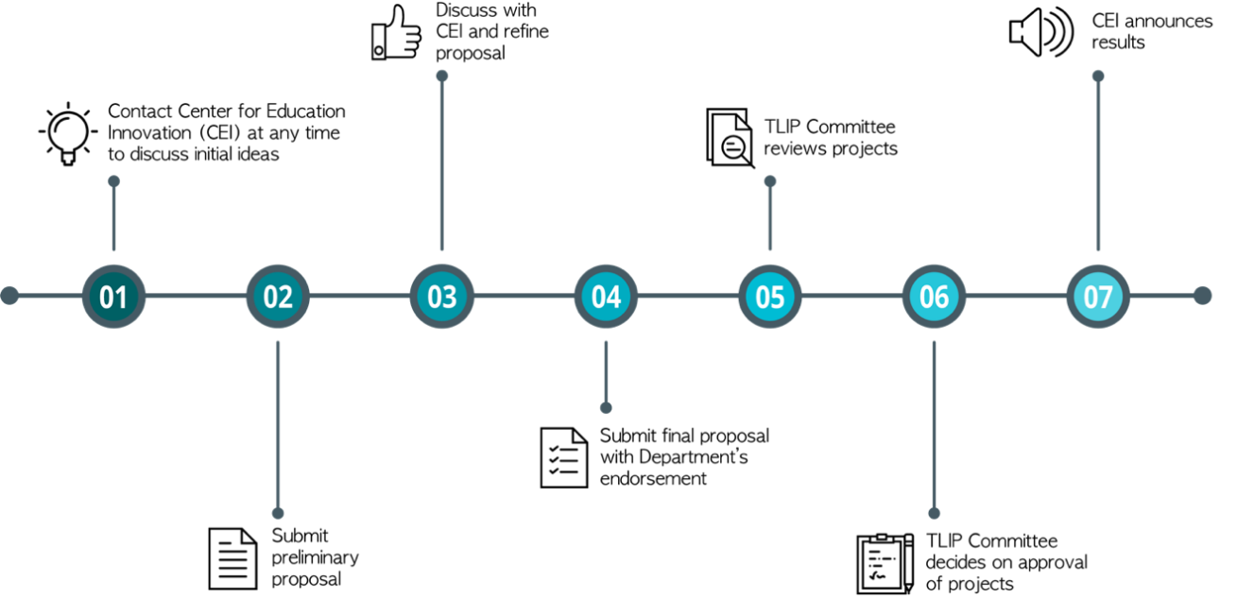

Application Procedures

- Preliminary proposal: Email to ceitdp@ust.hk by the specified deadline. Upon receiving your submission, CEI will contact you to discuss your idea and to provide advice to shape up the proposal.
- Final proposal: Email to ceitdp@ust.hk by the specified deadline. Please ensure that the proposal is endorsed and signed by relevant parties and mail the endorsed hardcopy to CEI (Room 6401), c/o Dr. Beatrice Chu.
- Idea presentation: In addition to the final proposal, applicants should submit a three-minute video or 10-slide deck describing the goal of your project and expected impact on teaching and learning. Each entrant should cover:
- The problem/opportunity that is being addressed. Examples:
  - problem: students lack opportunities to engage in authentic problem-solving experiences
  - opportunity: gamified e-learning modules promote engagement, provide instant feedback, and reinforce reflection
  - Description of the solution
  - Target/size of the beneficiaries (e.g. students / teaching faculty)
  - Value of the solution to teaching and learning
  - How this project will inform future teaching practices, course and/or curriculum design

Enquiries

For enquiries about application procedures and advice on strengthening the project ideas, please contact Dr. Beatrice Chu of CEI at beatrice.chu@ust.hk or ext. 8940.
Project Title

- Particulars of Project Team

Name | Post | Dept/Division/Center
Project leader(s):
Project member(s), if any:

- Abstract (about 200 words)
(Summarizing the project objectives and expected outcomes/deliverables in layman terms)

- Project Objectives (maximum 1 page)
(What drives the need for this project? How the project articulates with the curriculum improvement or innovative teaching and learning practices?)

- Project Plan and Methodology (maximum 2 pages)
(What is the scope of the project and the methodology/action plan to achieve the project outcomes and deliverables?)
All projects are encouraged to adopt the action research approach in the design and implementation process. For details, please see http://cei.ust.hk/teaching-resources/action-research.

- Project outcomes and tangible deliverables
(What are the expected outcomes/benefits/deliverables of this project? Please also specify the impact on student learning that can be supported by direct evidence of outcomes.)

- Project monitoring and evaluation on the learning impact on students
(How will this project be evaluated to assure its effectiveness in achieving the expected outcomes and attaining the project objectives?)

- Applicable program(s)/course(s)

Program(s)/Course(s) | No. of students | Semester/Year

- Project Schedule and Implementation Plan

Proposed Start Date: |  |  |  | (dd/mm/yyyy)
Proposed Completion Date: |  |  |  | (dd/mm/yyyy)
Expected duration: |  | year(s) |  |  | month(s)

Project implementation Timeline:

Period (mm-yyyy) | Planned actions / Key milestones

- Budget Breakdown and Justification
(Clear justification of budget items must be provided. Equipment and teaching material expenses, which should be covered by the relevant School/Department, are NOT normally covered)

Note: Basic monthly salary includes MPF (5% of monthly salary with cap), gratuity, medical and group life insurance (1.6% of monthly salary). If the appointment is to last for more than 12 months with consideration of salary increment, this cost should be incorporated in the budget calculation to avoid the situation of overspending by the closure of the project. Otherwise, please consider offering a fixed term appointment (i.e. no salary adjustment during the whole employment period). For details of the salary calculation, please consult HRO or your department administrative staff.

- Staffing

Position | Responsibilities (please give details) | Salary* | Employment Period | Budget Required
Subtotal of (a)

*Remember to break down each salary into basic salary, MPF (5% of monthly salary), medical and group life insurance (1.6% of monthly salary).
*Remember to arrange a dedicated working area with your department/division (i.e. table, chair or any required equipment) to ensure an effective working environment for the new staff to deliver their responsibilities

- Consumables

Item | Budget Required
Subtotal of (b)

- Other funding sources (For example, matching funds from department/school)

Funding source | Funding amount
Subtotal of (c)

Total Budget Required: |  | (a + b)
Total Budget Requested: |  | (a + b - c)

(Funding limit is $250,000)

- Sustainability (How can this project sustain after the funding is over?)

- Copyright Declaration
You will be responsible for clearing all copyright issues for content development. Written consent from the copyright holder will be required before any duplication, conversion, printing or graphic production request can be implemented.

CEI may at its discretion use any graphic, photographic, AV and multimedia materials contained in these productions for university related publications for all media, unless restriction against such use is explicitly spelt out in writing before the project commences.

I (name of the Project Leader) have read the current Copyright Ordinance (http://www.ipd.gov.hk/eng/pub_press/publications/cpr_ed_e.pdf) concerning the education sector and declare that I will observe the copyright regulations and take full responsibility for the use of all copyrighted materials in my TDG project.

Signature:

Name, Department:

- Endorsement from Head of Department:
This teaching development project is supported and endorsed by:

Signature:

Name:

Date:

Comments:

